**Aim:-** Design a Counter using 7- Segment Display, LDR and CD4027 ic.

**Requirements:-**

1. CD4027 ic.
2. Resistor *7 (680ohm).
3. Resistor*2 ( 1.5k).
4. 7 segment display.
5. Connection pins
6. Push button.
7. Wires.
8. Battery.
9. LDR.

**Theory:-**

In this circuit, the LDR is connected to the input pin of the CD4027 IC. When the light level changes, the resistance of the LDR changes, which triggers the IC to count up by one. The clock signal is provided by a 555 timer circuit, which is connected to the clock input of the IC.

The output pins of the IC are connected to a seven-segment display, which shows the current count value. When the count reaches 9, it resets back to 0 and starts counting again.

Note that this is just one example of how you can use the CD4027 IC and LDR to create a 0 to 9 counter. There are many variations and modifications that you can make to this circuit to suit your specific needs and requirements.

**Procedure:-**

To create a 0 to 9 counter using the CD4027 IC and LDR, you can follow these steps:

1. Connect the power supply to the IC.

2. Connect the LDR to the IC's input pin.

3. Connect the output pins of the IC to the seven-segment display.

4. Use a clock signal to trigger the IC and advance the count.

5. Set the IC to count up from 0 to 9.

6. Adjust the LDR to change the light level and trigger the IC to count.

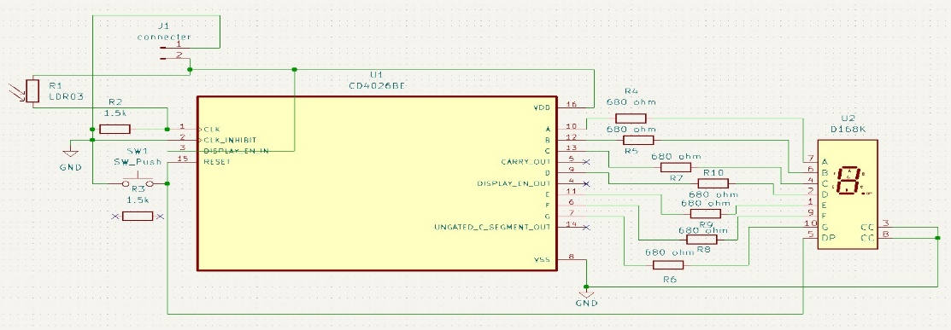**Circuit Diagram:-**

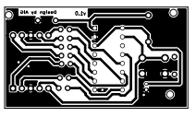**PCB layout:-**

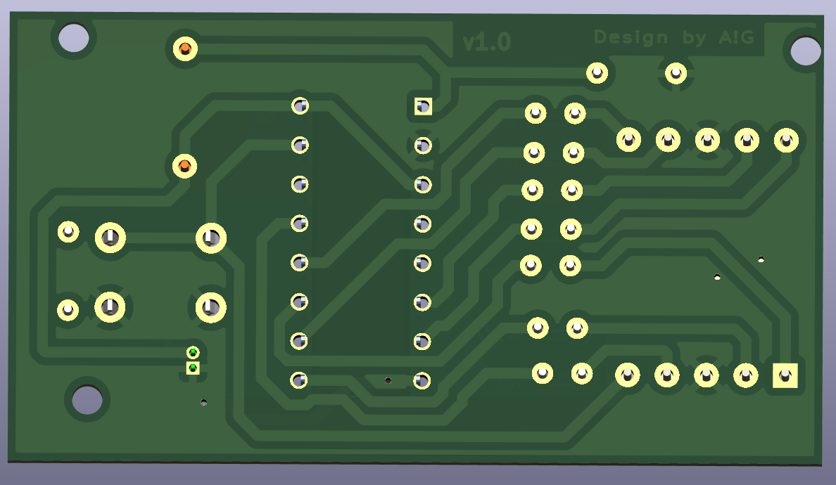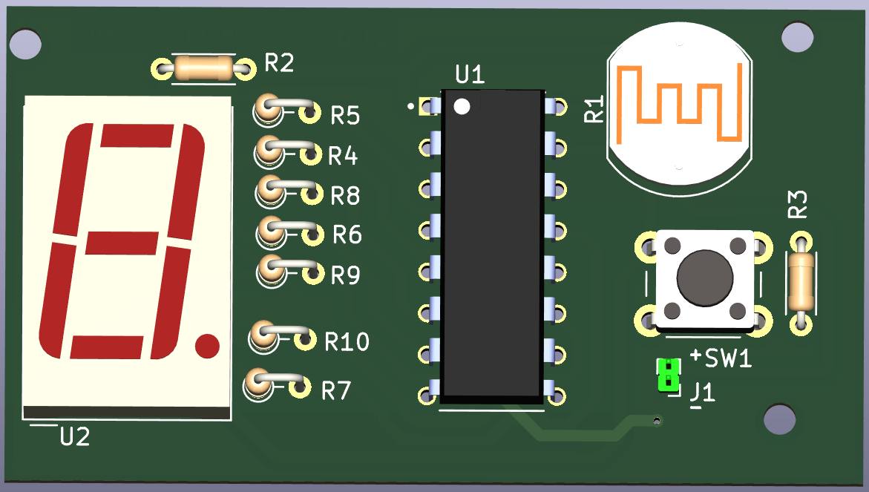**3D model of PCB:-**

For the design purpose I have use professional tool kicad which is a open source for all. And easy to handle. There are many cad tools are available like altium , easyEDA, Eagle, protues etc.

**Results:-**

This is a video link:-

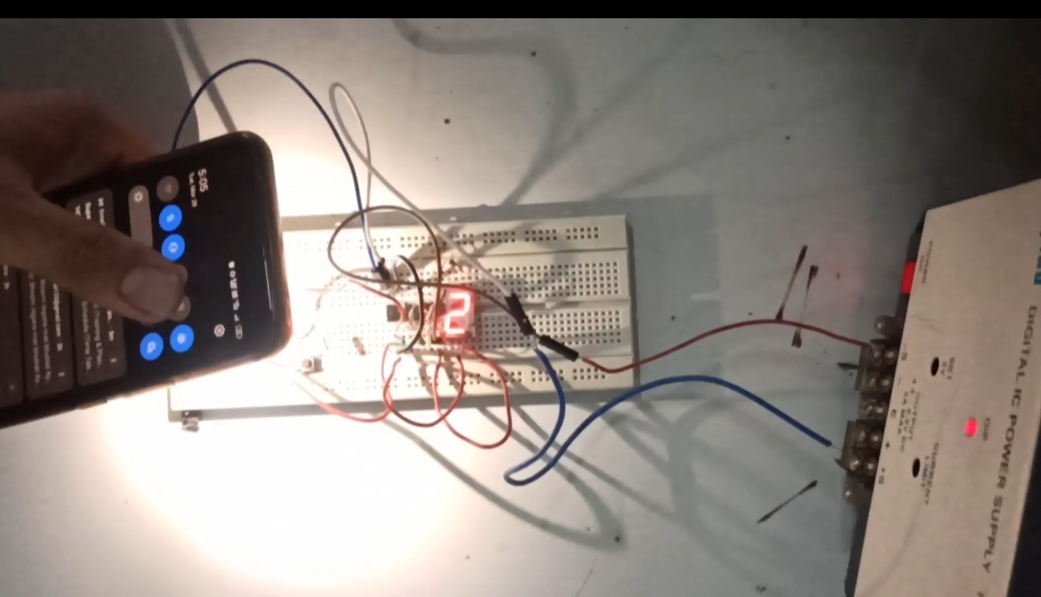[**https://youtube.com/shorts/y2fSaoZkrY8?feature=share**](https://youtube.com/shorts/y2fSaoZkrY8?feature=share)

**Final PCB:-**

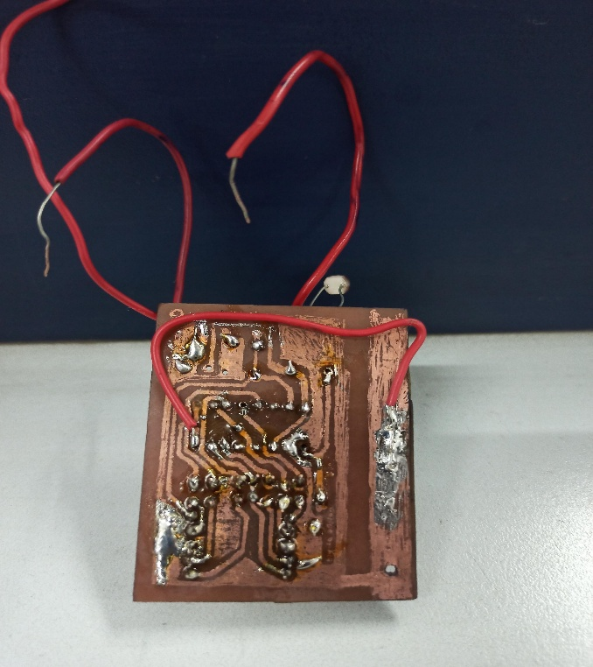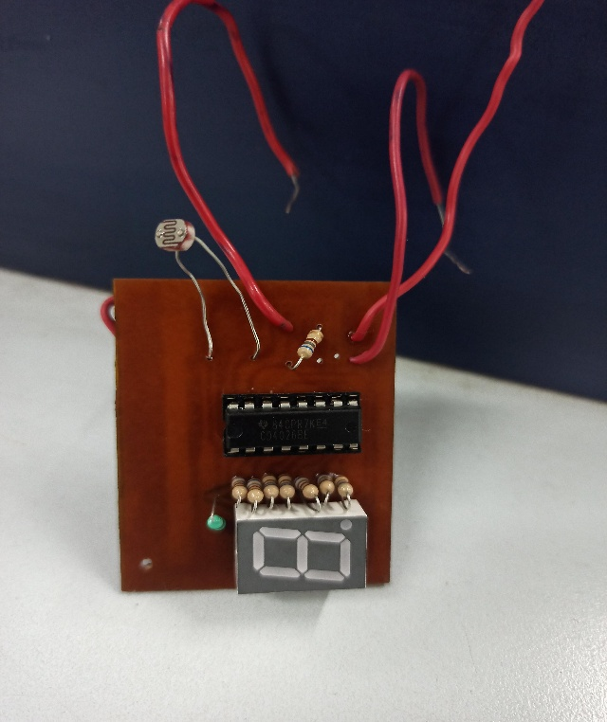

**Future scope:- By doing some modifications on the above circuit, we can use it an emergency head count. This will be use for Accurate Vehicle counting in Night time where advance machine hardly work.**

**QR code:-**